1st Workshop on Polarized Beam and Target–Physics and Applications Feb.26–28, 2024, Huizhou, China
Paper Title*
Author1¹，Author 2²，Author3 ¹
( 1. Author1's affiliation, City name Zip code， Country；
2. Author2's affiliation, City name Zip code， Country)

Abstracts: The abstract should contain the essence of the article and the results obtained.

Key words: Three to five key words should be provided.

PACS Number: (optional, please provide it if you know) DOI：

1 Paper format
PBT2024 participants can prepare the manuscript in LaTex format and Word format with PBT2024 NPR templates. The LaTex format is preferred. The contribution to PBT2024 proceedings is about 6 journal pages. If necessary, special request of additional pages can be put forward and consulted with the LOC team and NPR Editorial Office. The paper should be with chronically numbered figures, tables and references. Abstract and 3–5 Key words, followed by the PACS number(PACS).
The following information should appear in the footnote of the first page: Foundation item, Biography and Corresponding author in the format as
(1) Foundation item: The sponsorship with the grant number or contract number.
(2) Biography: Name (Year of Birth―), male/female (Nationality), Place of birth, Degree/Title, Research field; E-mail address.
(3) Corresponding author: Name, E-mail address. The item can be neglected if the corresponding author is the first author of the paper.

2 Figures
Figures must be numbered and be referred to in the text. Each figure with a separate caption should be placed in an appropriate place. Axes of figures must be labeled properly. In addition, in order to be convenient for the NPR editorial office to edit the figures, please supply us the original (data) files, such as the *.OPJ, *.DWG, *.CDR format etc. if the figures are drawn with the softwares of Origin, CorelDraw, AUTOCAD and so on. Otherwise the high resolution original figures in TIF, EPS, JPG, BMP formats etc. should be sent as the attachment files together with your submission manuscript to NPR. For example:

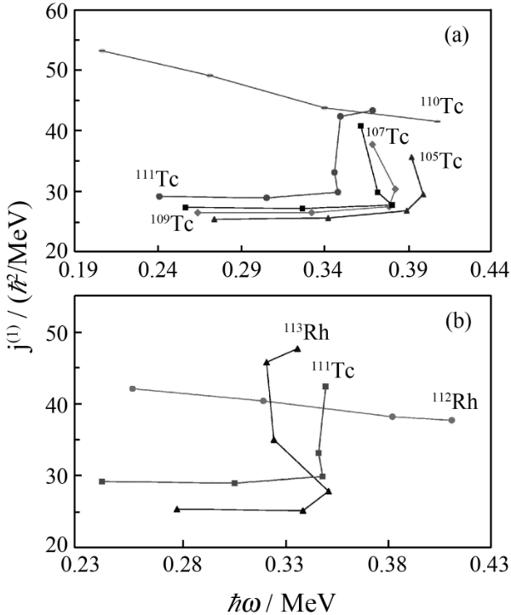

Fig 1. (a) J⁽¹⁾s plotted against rotational frequency for the ground-state bands of the even-N Tc isotopes. Those of the odd-N ¹¹⁰Tc are also shown. (b) The same as (a) but for the N=68 isotones ¹¹³Rh and ¹¹¹Tc. J⁽¹⁾ of the odd-N ¹¹²Rh is also shown. Data taken from the new level schemes reported in ^{[8,9,11]}.

3 Equation
Equations can be written by using the MathType environment or by inserting Microsoft Equation object, for example:
x. (1)
4 Tables
Each table should have a number and a title and should be inserted into an appropriate place. The table should be written in a three-line form. For example:

Table 1 Title
ρ₀ /fm⁻³ | E₀/MeV | K₀/MeV | S(ρ₀)/MeV
-16.01 | 234 | 30.00 | 243
-15.95 | 234 | 34.00 | 256
-15.90 | 230 | 37.53 | 263
-15.97 | 32.01 | 36.64 | 248

5 References
The references should be numbered at the right place of the first appearance in the text and every reference should be identified properly at where it is cited. The format of the references list is as follows.
(1)Journal articles:
Example: PEREGO A R D, LOGOTETA D. Phys Rev Lett, 2022, 129: 032701.DOI: 10.1103/PhysRevLett.129.032701.
(2)Books:
Example: WOLSKI A. Beam dynamics in high energy particle accelerators[M].London: Imperial College Press, 2014: 85.
(3) Proceedings:
Example: PEZOA F, REUTTER J L, SUAREZ F, et al. Foundations of Json Schema[C]//Proceedings of the 25th International Conference on World Wide Web. International World Wide Web Conferences Steering Committee, USA: IEEE, 2016: 263
(4) Dissertations:
Example: SHUANG R. Extraction System Design and Beam Dynamics Study of the HIAF-bring[D]. Beijing:University of Chinese Academy of Sciences, 2018: 20..
(5) Preprint:
Example: ZHENG R Y, SUN X X, FANG SHEN G, et al. arXiv: 2309.08443, 2023.
References:
[1] PEREGO A R D, LOGOTETA D. Phys Rev Lett, 2022, 129: 032701.DOI: 10.1103/PhysRevLett.129.032701.
[2] WOLSKI A. Beam dynamics in high energy particle accelerators[M].London: Imperial College Press, 2014: 85.
[3] HANAUSKE M, YILMAZ Z S, MITROPOULOS C, et al. Gravitational waves from binary compact star mergers in the context of strange matter: volume 171[C/OL]. 2018: 20004. DOI: 10.1051/epjconf/2018
17120004.
[4] PEZOA F, REUTTER J L, SUAREZ F, et al. Foundations of Json Schema[C]//Proceedings of the 25th International Conference on World Wide Web. International World Wide Web Conferences Steering Committee, USA: IEEE, 2016: 263.
[5] SHUANG R. Extraction system design and beam dynamics study ofthe hiaf-bring[D]. Beijing:University of Chinese Academy of Sciences,2018: 20.
[6] ZHENG R Y, SUN X X, FANG SHEN G, et al. arXiv: 2309.08443,2023.
[7] XIAO Y. Information highway[EB/OL]. [2023-09-15]. http://www.creader.com/news/200112190019.htm.
[8] International Organization for Standardization. ISO 80000-2, quantities and units: Part 2: Mathematical signs and symbols to be used in thenatural sciences and technology[S/OL]. 2nd ed. ISO, 2019. https://www.iso.org/standard/64973.html.

* * Received date:： yyyy-mm-dd; Revised date：yyyy-mm-dd Foundation item:：The sponsorship with the grant number or contract number. Biography: Name(Year of Birth―), male/female(Nationality), Place of birth, Degree/Title, Research field; E-mail address. Corresponding author: Name, E-mail address. The item can be neglected if the corresponding author is the first author of the paper.

